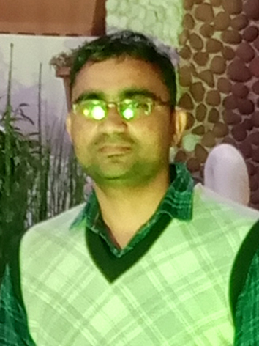

**ATUL KUMAR (QA Software Engineer)**

* atul_infotest@yahoo.com

 +91 7500428994, +91 8958794934

* Noida

**Personal info:-** Software engineer with hands-on experience in all levels of testing, including Performance, Functional,

Integration, System, and user acceptance.

Objective :- To get an opportunity where I can make the best of my potential and contribute to the organization's growth

**Personal Details :**

Gender : **Male**

Nationality :  **Indian**

Civil Status : **Unmarried**

DOB  **: 10-07-1994**

**Skills :**

* **Manual Testing**
* Smoke Testing, Sanity Testing, Regression Testing, System testing , Retesting .
* Experience in developing Test Scenario, Test Case closure report and Bug Report
* Good Knowledge of SDLC & STLC.
* Good Knowledge of Agile scrum methodology
* Good Knowledge of Defect life Cycle process.
* Good Knowledge of Load Testing
* Basic Knowledge of **Mobile App Testing**
* Basic Knowledge of **API Testing using Postman**



**Tools :**

* **JIRA**
* **Postman**
* **My SQL Workbench**
* **JMeter**
* **MS Excel**

**Education :**

**MBA(IT)**  **Jul 2017- Jun 2019**

AKTU University –Lucknow UP

**B.sc**  **Jul 2012- May 2015**

Dr. B R A University –Agra UP.



**Employment :**

**QA Engineer Mar 2021- Present**

I3 Info soft Pvt. Ltd Noida

* Understanding & Analyzing requirements for the SRS document.
* Write and execute test scenarios and test cases.
* Shared the test case executed report to team members
* Verifying bug fixes.
* Perform Smoke , Regression, Sanity and Data validation Testing
* Attending daily scrum meeting
* Issue Resolution/Status reporting to Product Owner.



**Extracurricular Activities :**

* Participate in all Agile/ Scrum Ceremonies.
* Writing Test Plan and Test Cases.
* Working in Agile Software Development methodology

|  |
| --- |
| **PROJECTS :**  **Project 2: On going**  I3 Infosoft Pvt. Ltd Noida  Related To: E-Learning Application  **Project 1:** S M Resource  **Company:** I3 infosoft Pvt. Ltd  **Domain :** https://www.searchmarketingresource.com/  **Team Size:** Nine Members  **Description:** S M Resource is a Digital Marketing & Web design application, used to manage overall resources of Digital Marketing , like registering a B2B & clients , Web design , Social Media , SEO Plan etc.  **Tools used:** JIRA for bug reporting and tracking, POSTMAN,  MS Excel.  **Declaration :**  I consent to the processing of my personal data for the purpose of recruitment for the position to which I am applying.  Date:  Place: Noida (Atul Kumar) |